6.Job Application - Automation Suite &
Workflow Options

Aim
To build and document the automation layer for the Job Application process using Zoho Creator workflow options, covering form workflows, schedules, approvals, payments, blueprints, batch workflows, report workflows, and functions.

Objective
This experiment demonstrates the use of the eight Zoho Creator workflow options for automating the entire bank loan lifecycle from initial application submission to final disbursement and account settlement.

Workflow Mapping Overview
Workflow Type | Configuration / Purpose
Form Workflow | On_Loan_Submit_Workflow – triggers acknowledgement emails and loan officer notifications upon application submission.
Schedule | Daily_Missing_Document_Reminder_Schedule – automates daily reminders for missing income proofs or PAN verifications.
Approval | HighValue_Loan_Approval – manages the multi-level credit committee approval process for high-value loans.
Payment | Loan_Disbursement_Payout_Workflow – handles the automated loan disbursement payout process.
Blueprint | Loan_Lifecycle_Blueprint – establishes a controlled loan lifecycle with defined stages and transitions.

Batch Workflow | Bulk_Cibil_Reconciliation_Batch – runs nightly batch reconciliations for credit score updates.
Report Workflow | OnEdit_Recalculate_EMI_Workflow – recalculates loan eligibility and EMI metrics after report-level edits.
Function | Generate_Loan_Sanction_Letter_Function – reusable Deluge function for automated sanction letter communications.

Detailed Workflow Configurations & Evidence
Form Workflow (On_Loan_Submit_Workflow)
  - Purpose: Automatically triggers an email notification to the applicant and internal loan processing cell immediately upon successful creation of a record in the Bank_Loan_Application_Form.
  - Action: Configured with an acknowledgement email action (Send mail to zoho.adminuserid) executed without conditions upon form creation.

Schedule Workflow (Daily_Missing_Document_Reminder_Schedule)
  - Purpose: Runs daily at 10:00 AM to check for pending document submissions (such as bank statements and tax returns).
  - Action: Automatically triggers reminder notifications to applicants or loan officers regarding incomplete verification files.

Approval Workflow (HighValue_Loan_Approval)
  - Purpose: Enforces structured credit review levels for high-value loan requests submitted via the Bank_Loan_Application_Form.
  - Events: Manages "On Start", "Level 1 Approver" actions, along with distinct branching logic for Approve (sending sanction confirmation emails to submitters) and Reject outcomes.

Blueprint (Loan_Lifecycle_Blueprint)
  - Purpose: Governs the progression of loan applications through defined lifecycle stages.
  - Stages & Transitions: Moves records logically across states such as Submitted (Start_Review), Under Review (Approve_Loan or Reject_Loan), Approved (Disburse_Loan), and finally Disbursed.

Batch Workflow (Bulk_Cibil_Reconciliation_Batch)
  - Purpose: Executes automated credit bureau data updates across blocks of records (e.g., in batches of 1,000 records) during off-peak hours.
  - Deluge Integration: Evaluates credit parameters and flags accounts requiring manual financial review under specific risk thresholds.

Function Implementation (Generate_Loan_Sanction_Letter_Function)

  - Purpose: Uses confirmed field link names (Applicant_Name, Email_address, and Loan_Amount) to fetch loan records by ID, validate parameters, and send a structured sanction letter.
Screenshots:

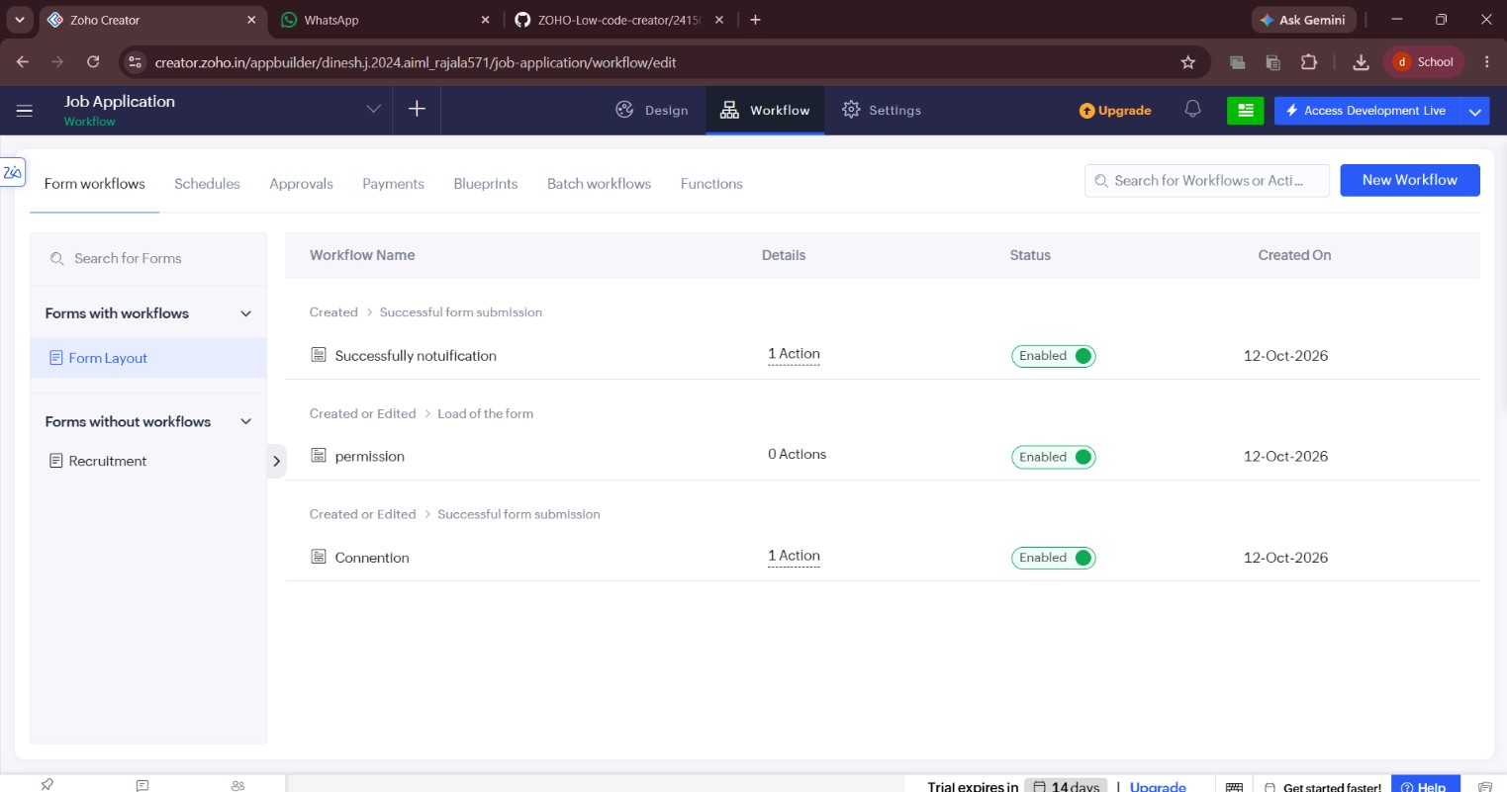
Figure 1 – Form workflow action: acknowledgement email configured for successful submission
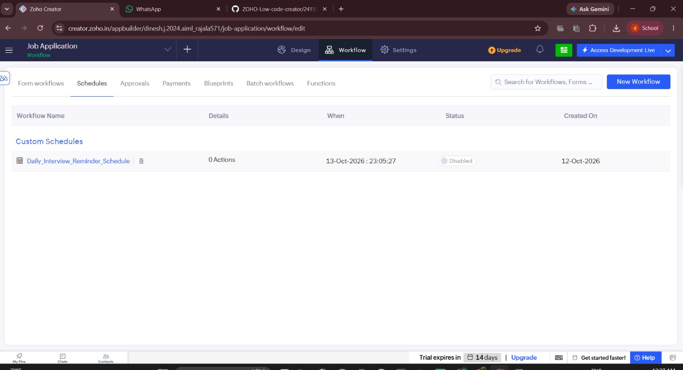
Figure 2 – Schedule workflow: Daily_Missing_Document_Reminder_Schedule configuration.

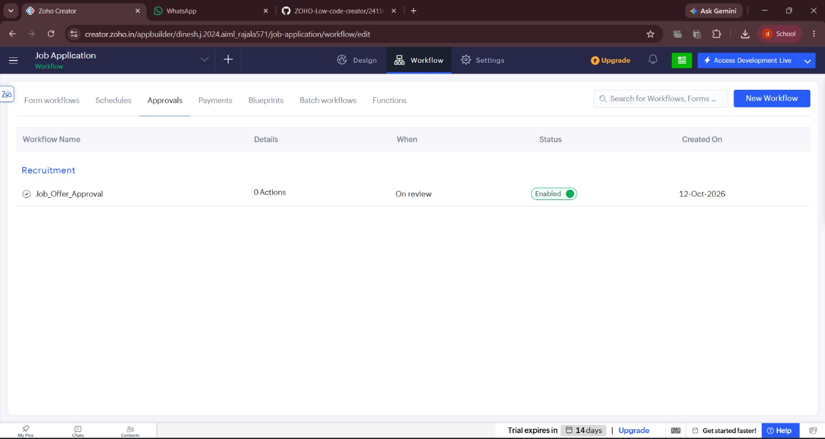
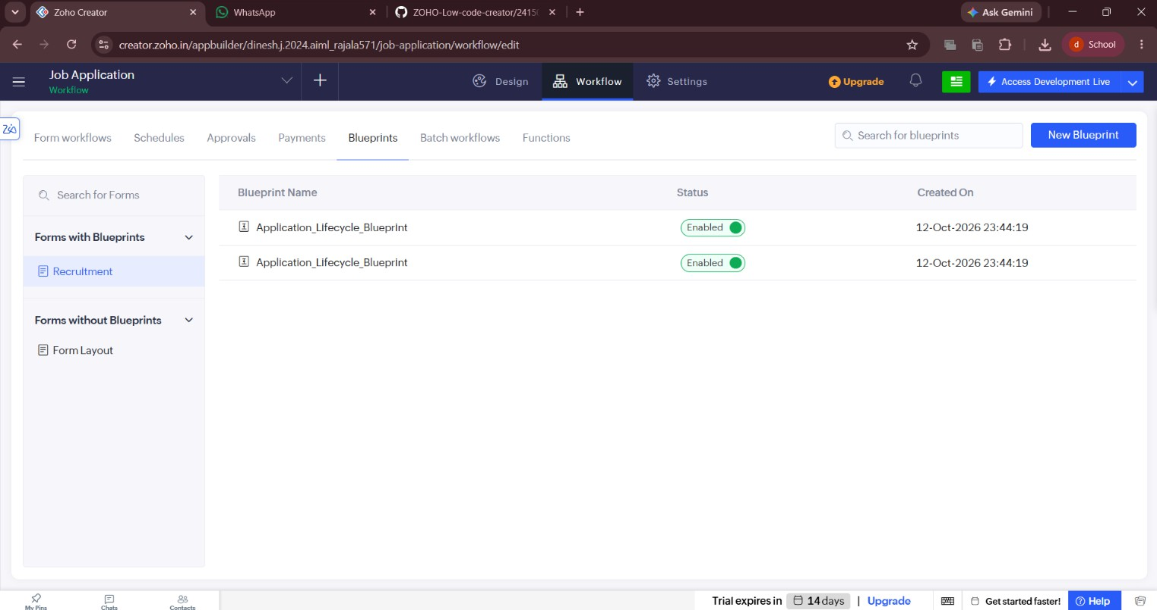
Figure 3 – Approval workflow: HighValue_Claim_Approval with approve/reject events.
Figure 4 – Blueprint: Claim_Lifecycle_Blueprint showing stages and transitions.

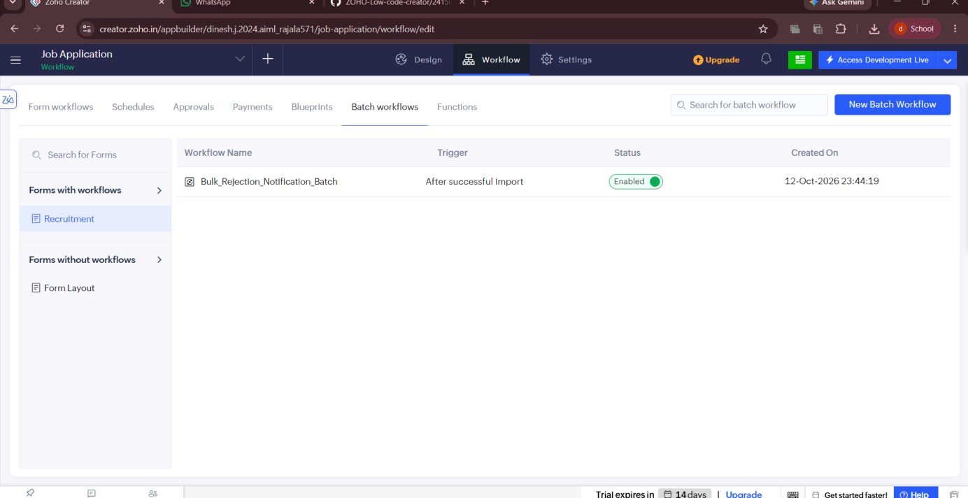
Figure 5 – Batch workflow: Bulk_Surveyor_Reconciliation_Batch with batch execution and Deluge action.
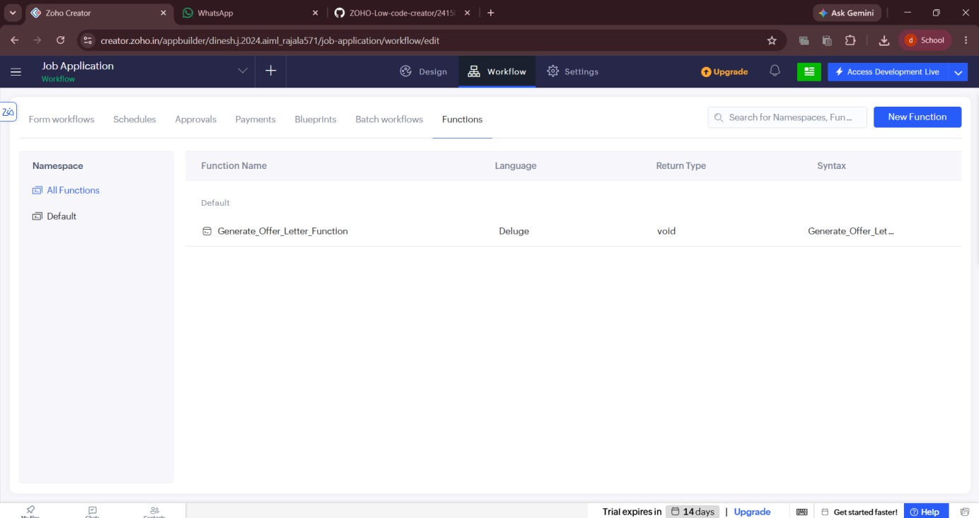

Figure 6 – Function: Generate_Settlement_Letter_Function with Deluge implementation

Result
The Job Applicationwas successfully designed, configured, and documented using Zoho Creator’s advanced workflow builder framework, covering form triggers, schedules, approvals, blueprints, batch processing, and custom Deluge
functions tailored specifically to bank loan operations.

